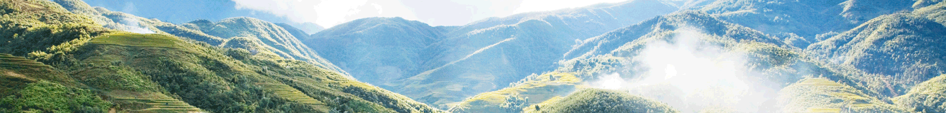

The Best Trail Of Trekking in Sapa

Destination: Sau Chua – Sa Seng – Hang Da – Hau Thao  Tour code: SPTTA002  Duration: 1 Day  Start from: Sa Pa Town  Stop off: Sa Pa Town | For all of you outdoorsy adventurous types, this day trek adventure through the Den Thang Mountains in the Sa Pa District in Vietnam is what you’re looking for! If it’s your first time, or even if you’re an avid trekker, this fun and active outdoor activity will take you to see the scenic beauty of the lesser known parts of Vietnam. This personal guided day trek departs from the Sa Pa Vietnam and will take you through the breath-taking and beautiful surrounding valleys and up along the Den Thang Mountains. You’ll discover the spectacular Hoang Lien mountain range and have a memorable journey meeting the locals, experiencing the unique culture of Hmong people.

No of passengers | 1 person | 2 persons | 3 persons | 4 persons | 5 persons | 6 persons | 7 persons | 8 persons | 9 persons | 10 persons
Tour price | 55.00  US$ | 32.00  US$ | 28.00  US$ | 25.00  US$ | 22.00  US$ | 21.00  US$ | 19.00  US$ | 18.00  US$ | 17.00  US$ | 16.00  US$

DETAIL INTINERARY:
Depart from: Hanoi Old Quarter
Stop off: Hanoi Old Quarter

Be ready at your hotel in Sapa at about 09:00am, our local guide and driver for a short road transfer along of main road northeastwards to the starting point of trekking. Hiking uphill on a rocky path for 2 hours along the narrow valley which runs between two high mountains passing two villages of the Black H'mong people: Sau Chua and Sa Seng.
The H'mong people here have just recently changed their living way from swidden cultivation style into the sedentary one. So there are still a lot traces of the past time can be seen: rudimentary houses, stone wall around houses... Lunch break in the village.

After lunch, we continue along the same trail gradually uphill the Den Thang mountain for an hour to Hang Da Village of the H'mong which sits at 1,800m height and over looking down the Muong Hoa Valley. Paying visit to several local houses.

Leaving Hang Da and enjoy easy walk on high elevation for half an hour which offers great view of Muong Hoa Valley until arriving to Hau Chu Ngai, another village of the Black H'mong. This portion of the trek offers chances for taking the best photos of landscapes.

Getting downhill for another hour along a dirt track to Pho Village at the center of Hau Thao Commune. You will be picked up from here to get back to Sapa.

Duration: 1 day | Tour Grade: Moderate | Length of trip: 18km of trek | Type of trip: Private Tours

Inclusion
Full transportation as tour program indicated.
Picnic Lunch
English- speaking guide.
Sightseeing fees.

Exclusion
Tips
Personal expenses
Emergency transfers

