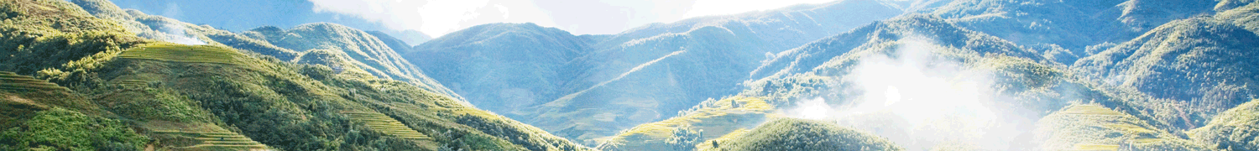

Sapa Tour by Bus from Hanoi with homestay

Destination: Ylinho - Lao Chai - Tavan - Giangtachai - Supan  Tour code: SPHB002  Duration: 2 Days/ 1 Night  Start from: Hanoi Old Quarter  Stop off: Hanoi Old Quarter | After 5 hour driving on a bus from Hanoi, you will be exploring Sapa and its beautiful southern valley for two days with one night home stay in Ta Van village of the Zay minority peoples. The trek from Sapa along Muong Hoa River, passing villages of the H'mong, Zay and Zao will offers spectacular scenery and a lot opportunities to get intact with local ethnic people.

No of passengers | 1 person | 2 persons | 3 persons | 4 persons | 5 persons | 6 persons | 7 persons | 8 persons | 9 persons | 10 persons
Tour price | 108.00  US$ | 83.00  US$ | 76.00  US$ | 71.00  US$ | 68.00  US$ | 66.00  US$ | 64.00  US$ | 62.00  US$ | 61.00  US$ | 60.00  US$

DETAIL INTINERARY:
Depart from: Hanoi Old Quarter
Stop off: Hanoi Old Quarter
Day 1: Depart from Hanoi to Sa Pa by bus - Trek to Lao Chai/ Ta Van (L,D)
6h30 - 7h00: The tour begins with a bus or taxi transfer to our office at 12 Ly Thai To, where you will catch the bus to Sapa
12h30 - 13h00: You will arrive Sapa town. Tourguide would pick up you there. Coming to hotel, rest for a short spell to take bath. You have any time to prepare your baggage for your trek. Then you have luch in your hotel. You should bring a little clothing, a comfortable shoes to trek.
14h00: You will begin yours 12 km trek on small trails down the Muong Hoa Valley toward the Black H'mong village of Lao Chai. The Muong Hoa Valley contains some of the most beautiful views of terraced fields in Asia. Continuing along the bottom of the Valley to go the Dzay tribe village of Ta Van to experience their way of life when you stay in a local family's cottage.
Day 2: Ta Van - Giang Ta Chai - Supan - Sapa (B,L)
After breakfast prepared by your guide, we continue to visit Red Dzao people at Dzang Ta Chai village where we also see a waterfall. The Red Dzao women have very colorful red embroidery and coins on their clothing. On their head they wear a red scarf. Some of them have shaved off their eyebrows because of a nice Red Dzao Legend.
We will walk to the rice paddy fields where we’ll have a nice photo session of the amazing surrounding landscapes. A trek through the bamboo forest soon follows which gives you the experience of Vietnam tropical jungle. Along the way, we will stop by a waterfall to have a panorama view of Dzang Ta Chai village and have lunch. Then walk to the main road to take a bus back to Sapa.
15h00: Back to Sapa and free time at leisure...
16h00: It‘s time to say “Good bye Sapa!” and drive back to Hanoi. Along the way, once again you have a chance to enjoy the magical beauty of the northwest mountains.
21h30: We arrive in Hanoi. End of services. See you next time! Take care.
Inclusion
- Welcome drink (tea, café), candy at our office
- Transport: Bus Sapa Express - Noble Limousine 29 seats is called "Special aircraft on the ground" with air-conditioner, travel blanket, pillow. Or Hung Thanh Express Bus
- Free water, wet tissue,... on Sapa Express Bus
- Transportation as programme
- Homestay at Tavan villiage of the Dzay family
- English speaking guide during the tour (enthusiastic, experienced)
- Meals as mentioned on itinerary.
- Entrance fees
Exclusion
- VAT (10%)
- Insurance, visas
- Other personal expenses (tip, drinks with meals,...)

