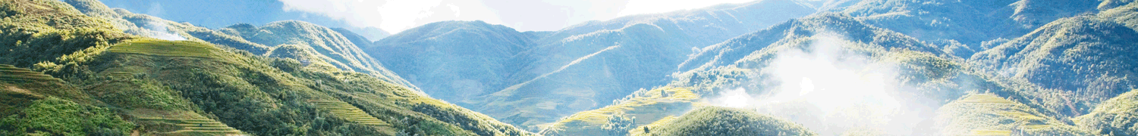
Sapa 2 Day Minority Trek - 1 night hotel stay by bus from Hanoi
Destination: Cat Cat - Sinchai - Ylinho - Lao Chai - Tavan  Tour code: SPHB001  Duration: 2 Days/ 1 Night  Start from: Hanoi Old Quarter  Stop off: Hanoi Old Quarter | On this trek you will explore the beautiful Sapa valley for two days with a one night at Panorama Hotel in Sapa. This trip is a wonderful opportunity to touch base with nature, admire the mountain landscape and views, feel revived and mingle with the humorous village residents. A lovely genuine Sapa experience.

No of passengers | 1 person | 2 persons | 3 persons | 4 persons | 5 persons | 6 persons | 7 persons | 8 persons | 9 persons | 10 persons
Tour price | 130  US$ | 103.00  US$ | 91.00  US$ | 86.00  US$ | 82.00  US$ | 80.00  US$ | 76.00  US$ | 73.00  US$ | 70.00  US$ | 68.00  US$

DETAIL INTINERARY:
Depart from: Hanoi Old Quarter
Stop off: Hanoi Old Quarter
Day 1: Hanoi - Sapa by bus with a short trek to Cat Cat village (L, D)
06:30: Pick up from the hotel, get on big bus and depart for Sapa
13.00: Arrive Sapa Town with colorful traditional costumes of H'mong, Dzao, Tay ethnic People.
The tour guide will be waiting for you at No.3 Fansipan Str (where the bus stop),
holding the sign "Sapa Pathfinder Travel" to welcome you. Then, please follow him to come to the hotel.
- Welcome drink and itinerary briefing
- Enjoy the lunch with local Vietnamese dishes, check-in procedures
14.30: A short trek to the gate of Cat Cat village which is home of Black H'mong ethnic people and is located near the bottom of a deep valley at the foot of Fansipan Peak. Our local guide will show you the daily life activities of the locals, trek down to the valley bottom to the waterfall where the French built a Hydro Power Station; stop for photo with bridge and waterfall then you will walk uphill for bus to pick up to get back to Sapa in the afternoon.
Trekking distance is about 3.5 kms and it lasts for 2 hours
17.00: Come back to Sapa Town.
Have dinner at the hotel's restaurant, Overnight in Panorama Hotel.
Day 2: Sapa - Hanoi by bus with a long trek Y Linh Ho - Lao Chai - Ta Van (B/L)
7.00 - 7.45: Have breakfast at hotel and prepare light pack for trekking
9.30: Trek from Sapa to Y Linh Ho then trek through the rice terraces and along Muong Hoa Stream to the Black Hmong village of Lao Chai to see the spectacular landscape of Hoang Lien Son Mountain.
12.30: Picnic lunch at Lao Chai Village
13.30: Heading to Ta Van village - home of Dzay ethnic people.
14.30: Bus picks you up at Ta Van Bridge to Sapa.
Trekking distance is about 12 kms and it lasts for 4.5 hours
15.00 - 15.30: Have a shower at shower room of our hotel.
15:30: The tour guide will take you to the bus stop
16:00: Get on bus to back to Hanoi.
22:00: Arrive in Hanoi. Trip ends.
Inclusion
- Pick up at your hotel in Hanoi
- Bus to Sapa: Sapa Express - Noble Limousine 29 seats is called "Special aircraft on the ground" with air-conditioner, travel blanket, pillow, Or Hung Thang Expres.
- Welcome drink (tea, coffee), candy at our office.
- Free wifi, water, wet tissue, bread, snack on Sapa Express Bus
- Transportation as program
- Panorama Hotel in Sapa town
- English speaking guide during the tour (enthusiastic, experienced)
- Meals as mentioned on itinerary (B: breakfast, L: lunch, D: dinner) .
- Entrance fees according to programme (Cat Cat village, Ta Van Village).
Exclusion
- VAT (10%)
- Insurance, visas
- Other personal expenses (tip, drinks with meals,...)

